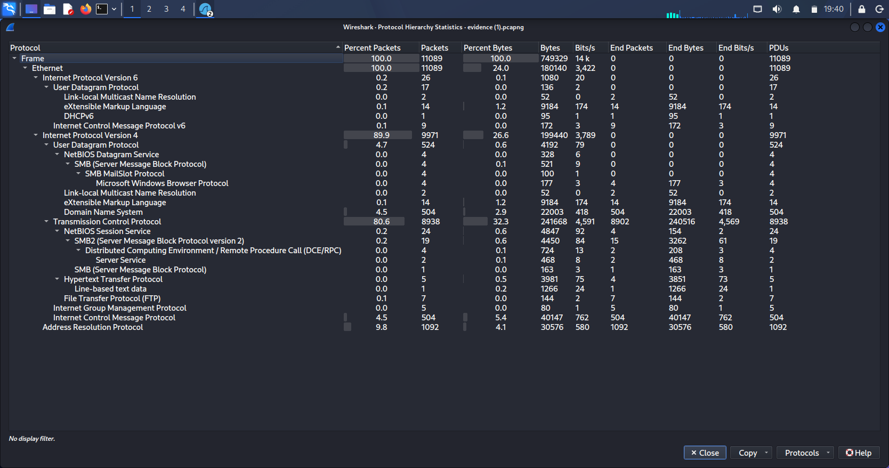
Task 2: Identify Malicious Indicators

1. Host Discovery Probing

The initial segments of the packet capture demonstrate rapid, alternating ICMP Echo Requests (Pings) and DNS queries passing between the host machines. This baseline signature matches early-stage passive asset discovery and host scanning layout setups.

2. Authentication Spraying / Brute-Forcing

Applying targeted application filtering isolated a heavy concentration of automated connection requests targeting the legacy FTP service daemon. The rapid frequency of authentication attempts followed by explicit server rejection messages serves as a definitive indicator of an active brute-force or credential-guessing attack profile.

Task 3 & 4: Reconstruct Communication & Data Leakage

1. Plain-Text Web Exposure

Reconstruction of the unencrypted web traffic stream (TCP Stream 4018) indicates that the target server is hosting a web application running on an obsolete and highly vulnerable server software package: Microsoft-IIS/5.0.
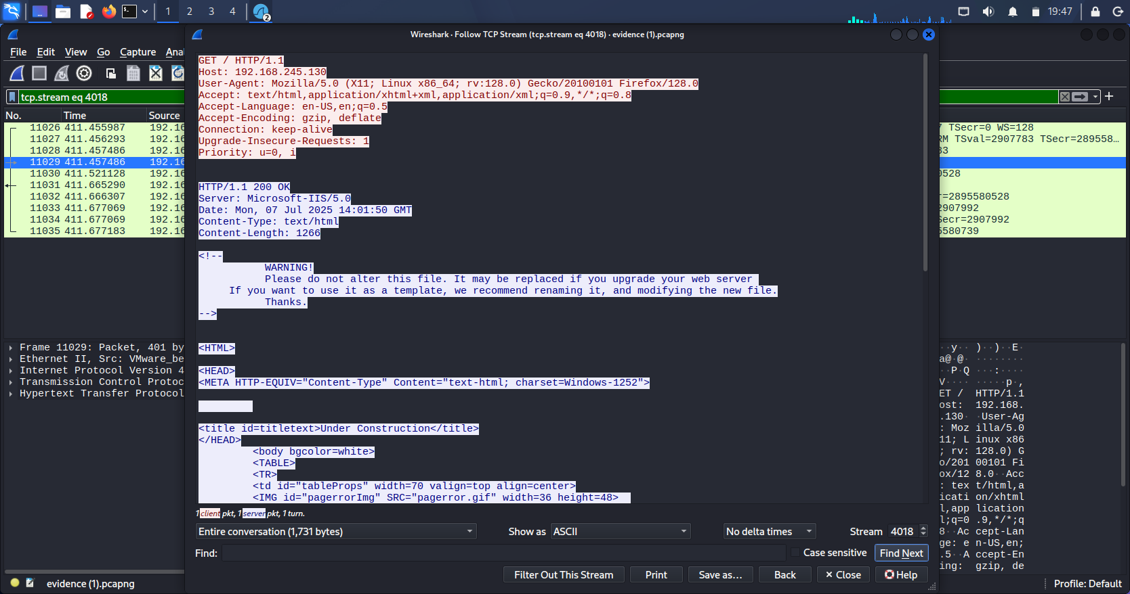

2. Credential Harvesting (FTP Analysis)
Because the services were deployed without cryptographic tunnel protection, the automated authentication sequence exposed sensitive security details in plain text over the wire. Under TCP Stream 4017, the following identity assets were cleanly harvested:

- Exposed Target Username: rahul

- Exposed Target Password: 1a2b3c

While the server dropped this specific session connection with an error flag (530 User rahul cannot log in), the attacker successfully captured a valid set of system credentials.

. 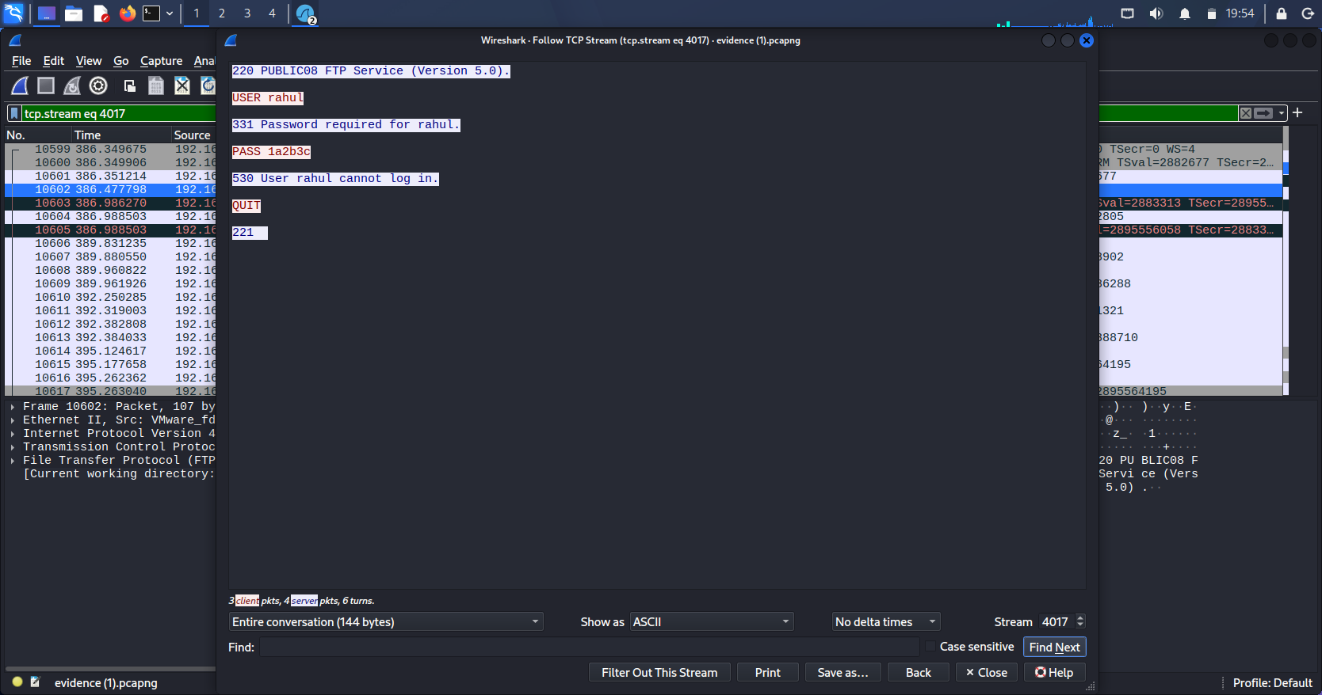

Task 5: Final Attack Scenario & Conclusion

1. Attack Timeline Sequence

1. Reconnaissance: The attacker (192.168.245.128) performed early network probing to find active hosts.

2. Credential Sniffing/Guessing: The attacker launched a brute-force sequence against the FTP service, harvesting the functional credentials for user account rahul.

3. Lateral Movement / System Intrusion: Armed with valid credentials, the attacker shifted away from the blocked FTP port and targeted the Windows file-sharing infrastructure (SMB/SMB2).

4. Successful Compromise: The attacker submitted an NTLM authentication request (NTLMSSP_AUTH) using the compromised account WORKGROUP\rahul. The server accepted the credentials, granting the attacker unauthorized remote terminal access to the administrative \\192.168.245.130\IPC$ inter-process communication network share.
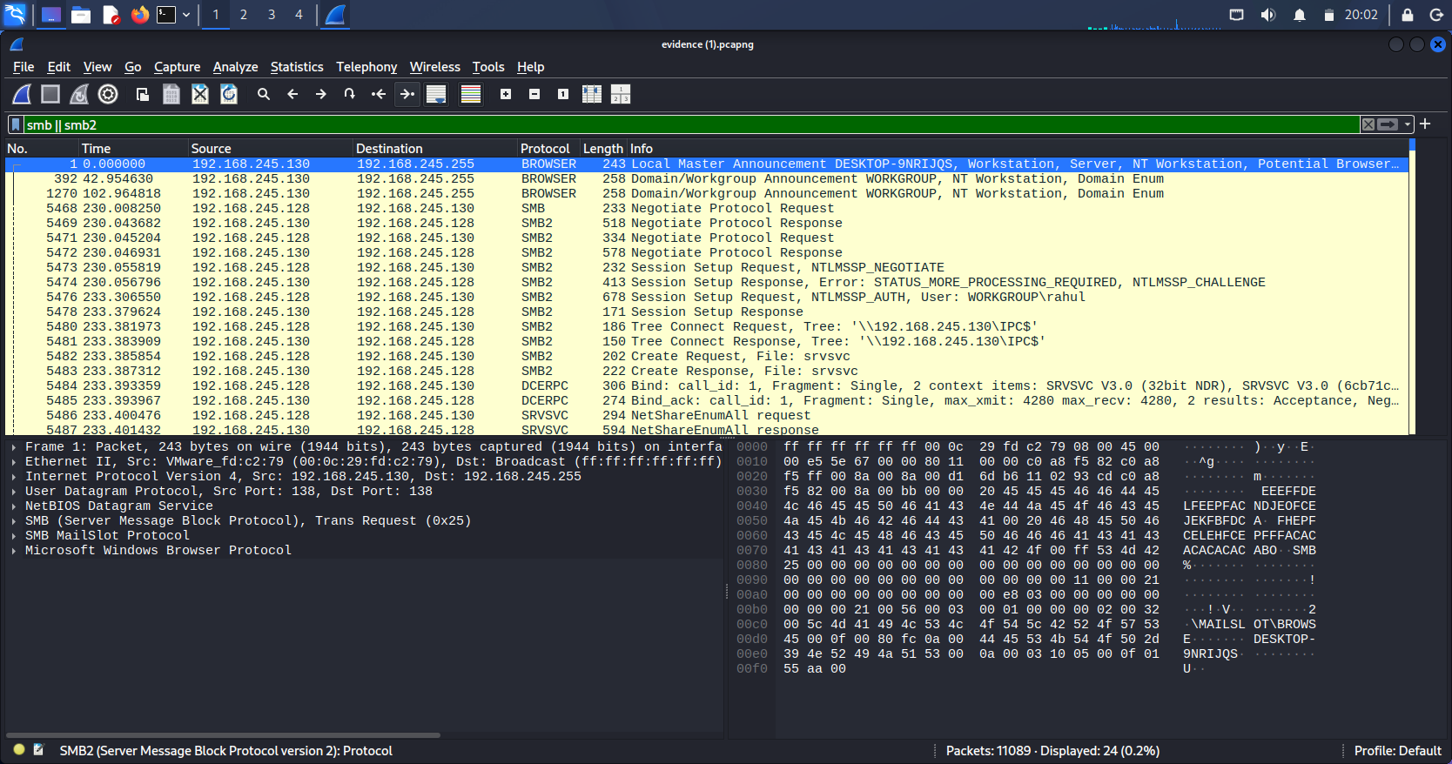
2. Mitigation Recommendations

- Disable Deprecated Services: Immediately decommission the legacy Microsoft-IIS/5.0 and old FTP service versions.

- Enforce Encryption: Upgrade all plain-text web interfaces to HTTPS (TLS) and force file transfers over encrypted protocols like SFTP.

- Account Remediation: Force an immediate global password change for the user account rahul across the entire domain workspace environment.

